Speck Cipher Analysis

<https://en.wikipedia.org/wiki/File:Speck_block_cipher.svg>

Algorithm

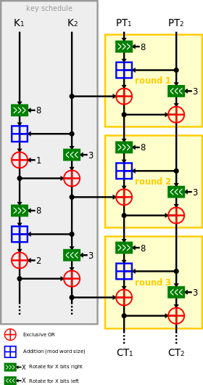

Encrypt- Rotates 8 bits right and 3 bits left or 7 bits right and 2 bits left for 16 bit words.

Decrypt- Rotates the opposite way in the same number of bits.